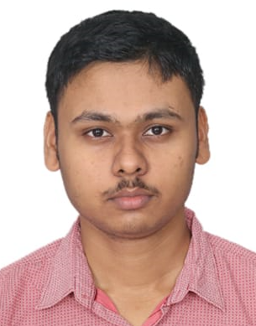

Email: s35102751@gmail.com

Phone: +91 9351695944

GitHub Profile: https://github.com/San123san

**Sanjeev Kumar**

**Technical Skills:** Java, HTML/CSS, JavaScript, React JS, Python, Node.js, Express.js, MongoDB, Next.js

**Certification:** Sales & Marketing, The Bits And Bytes of Computer Networking

|  |  |  |  |
| --- | --- | --- | --- |
| **EDUCATION** | | | |
| **Board** | **Tenure** | **Educational institution** | **CGPA/Percentage** |
| B. Tech CSE | Sep 2020 –Ongoing | VIT University, Bhopal | 7.58/10 |
| Class XII | May 2019 | Delhi Public School, Bikaner | 58.0% |
| Class X | May 2017 | Army Public School, Bikaner | 7.4/10 |

|  |  |
| --- | --- |
| **ACADEMIC PROJECTS** | |
| Full Stack  (Web Development) | * **Demo-Cherished-Memory-Project**   + **Description:** The website is a platform where user can upload your cherished memory with topics and description. And also user can see other memory.   + **Technology:** React, Express.js, Node.js, MongoDB   + **Role:** Full Stack Developer   + **Link** : https://github.com/San123san/Demo-Cherished-Memory-Project.git |
| Full Stack  (Web Development) | * **Demo_Project_Sign_Up**   + **Description:** The Demo_Project_Sign_Up is allow the user Sign Up.   + **Technology:** React, Express.js, Node.js, MongoDB   + **Role:** Full Stack Developer   + **Link:** https://github.com/San123san/Demo_Project_SignUp.git |
| Front End  (Web Development) | * **News Website**   + **Description:** The New Website is responsive website. This website provide users seamless news consumption experience. Also offering various section of Home, IPL, Politics and Finance.   + **Technology:** HTML/CSS, JavaScript, JSON   + **Role:** Front End Developer   + **Link:** https://github.com/San123san/New_website_demo.git |
| Extension | * **Title_Extension_Demo**   + **Description:** The Title Extension help the user to find the title of the page.   + **Technology:** HTML/CSS, JavaScript, JSON   + **Link**: https://github.com/San123san/Demo_Project_Ext.git |

|  |  |
| --- | --- |
| CO-CURRICULARS | |
| Coding | * Leetcode – Global Rank – 6,69,883 |

|  |  |
| --- | --- |
| EXTRA-CURRICULARS AND ACHIEVEMENTS | |
| Achievements | * More than 100+ question done in Leetcode |
| Responsibilities | * Administrative Advisor (Insight Club) 2022-23 |

|  |  |
| --- | --- |
| ADDITIONAL INFORMATION | |
| Hobbies | * Playing Games |
| Languages | * English, Hindi |